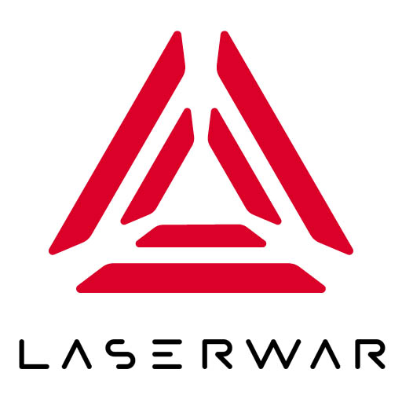
ОБЩЕСТВО С ОГРАНИЧЕННОЙ ОТВЕТСТВЕННОСТЬЮ
«ЛАЗЕРТАГ»

ПАСПОРТ

Смоленск
LIMITED LIABILITY COMPANY
LASERWAR

SPECIFICATION

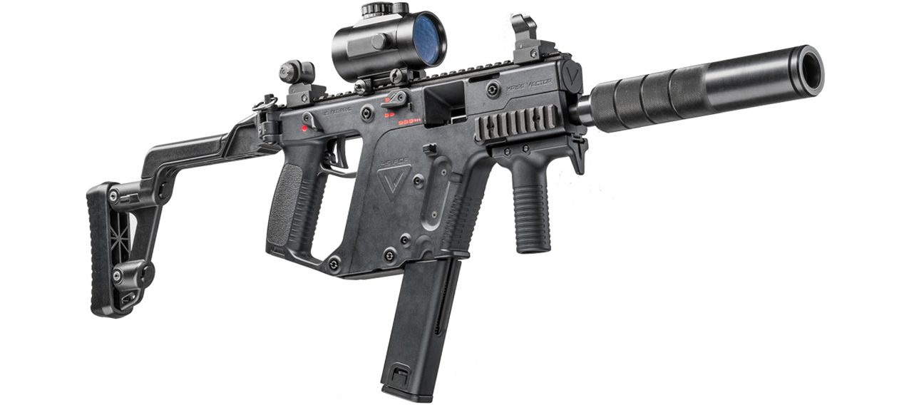

The X-generation game set
KRISS VECTOR ELITE EDITION

- Contact information
official website:
www.laserwar.com

e-mail:
info@laserwar.com
help@laserwar.com Purchase date:________________

skype:
info@laserwar.com
help@laserwar.com

_____________________
signature

Serial number:

Equipment version: v.10 X-GEN

Feedback OLED Parallax

Dear Customer!
LASERTAG LLC welcomes you and thanks you for choosing our products, and also expresses confidence that the product you purchased will bring you pleasure and will last a long time. This coupon establishes a warranty liability for the product in the amount provided by the Law of the Russian Federation "On Protection of Consumer Rights".
This warranty card is valid for 24 months from the date of purchase of the product subject to the terms of the guarantee.

2
11
- Purpose

The KRISS VECTOR game set of the "ELITE" series is a light and sound rifle designed for playing laser tag.

2. Technical characteristics
Weight | 3.55 kg
Length | 58/80 cm
Battery type | Li +; 2600 mAh
Charger type | Automatic, Li +
Battery life | 30 hours
Optimum range of fire | 150 m
Software | LASERTAG configurator

1. Package Contents
№  п/п | Name | Unit of measurement | Amount
1. | Light and sound rifle | PC. | 1
2. | Product passport | PC. | 1
3. | Tactical grip | PC. | 1

Information about the repairs carried out during the period of guaranteed service (to be filled in by the service center performing the warranty repair)

Date:__________________Completed work:  _____________________________________________________________________  Printing Service Center | Date:__________________  Completed work:  _____________________________________________________________________  Printing Service Center
Date:__________________Completed work:  _____________________________________________________________________  Printing Service Center | Date:__________________Completed work:  _____________________________________________________________________  Printing Service Center
Date:__________________Completed work:  _____________________________________________________________________  Printing Service Center | Date:__________________Completed work:  _____________________________________________________________________  Printing Service Center

3
10
4. Description and exploitation
4.1. Device
The game laser tag-kit KRISS VECTOR of the "ELITE" series consists of two parts - light and sound screws and bandages with damage sensors. The connection of weapons with the bandage is carried out with the help of Bluetooth technology.
The device of the KRISS VECTOR game set of the "ELITE" series is shown on the Scheme 1 and Picture 1.
Scheme 1

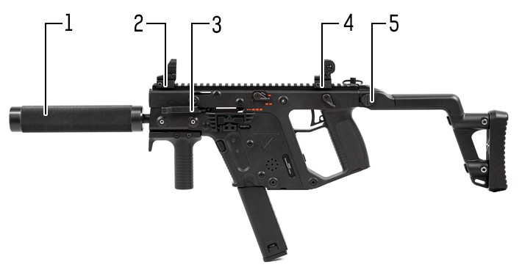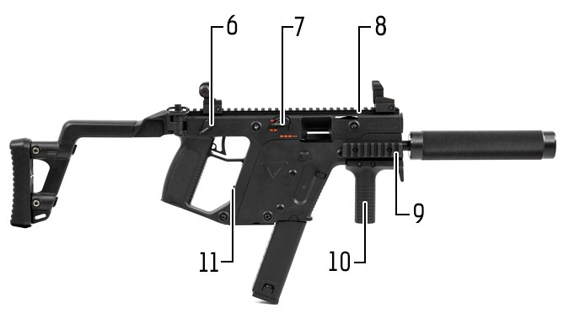

1 – optical system.
2, 4 – standard sighting devices.
3 – reload shutter.
5 – collapsible buttstock.
6 – safety lock.
7 – On/Off switch.
8, 9 – rail for additional equipment.
10 – tactical grip.
11 – power socket.

Terms of guarantee:

1. The guarantee becomes effective upon presenting the present coupon, which indicates the date of purchase of the equipment, confirmed by the service center.
2. These warranty obligations apply to products purchased only from the official representative of LLC LASERTAG, or its Official Dealer.
3. This warranty is void if defects in the product have occurred in the event of:
- non-observance of Instructions for use;
- mechanical damage;
- ingress of foreign objects, liquids, etc .;
- animal activities;
- unauthorized access to sites and details of persons who are not authorized to carry out specified actions;
- use of the product for purposes for which it is not provided;
- acts of force majeure (natural disaster, fire, accident, etc.);
- failure of the product due to improper connection, a faulty electrical outlet and / or poor maintenance of the product.
4. If the warranty card is lost, the duplicate does not issue.

4
9

  - Setting up the 10th generation equipment
See the 10th generation equipment exploitation manual:

https://drive.google.com/file/d/1905ZwWY4lOyp2kgPCSVE1AETAkO1-g2C/view?usp=sharing

4.3. Setting up the game set

Change of tactical and technical characteristics is carried out with the help of a single configuration program "LASER-TAG-configurator". The appearance of the LASERTAG configurator is shown in Picture 2.

3. Bandage. When using dressings, you should pay attention to the need for special hygienic cuffs that protect electronic components from moisture. If the dressing is wet during use, it can lead to the failure of electronics - it must be dried immediately.
In addition, when using bandages, you may encounter mechanical damage to the caps protecting the sensors. In such cases, the lid should be replaced. Recharge the dressings immediately after the game for no more than 80 minutes.
Store the equipment in a well-ventilated room at a temperature of + 18 ° C to + 30 ° C and relative humidity of 45 to 65%.Store the equipment only in a charged state (ideally - at the rated voltage of the battery).

6. Warranty

The manufacturer guarantees the reliability of the individual set of LASERWAR when the user observes the operating conditions consumer complies with the rules of transportation, storage, operation and payment for the delivery of faulty equipment. The manufacturer undertakes to replace or repair the individual set of equipment free of charge, provided that the to the city of Smolensk.
On the batteries, speakers, IR-modules warranty is 14 DAYS.
ATTENTION! In the event of improper use of batteries (charging by an inappropriate type of charger), the battery warranty does not apply!

With full technical guidance on the operation of LASERWAR laser equipment, you can visit our website at www.laserwar.com

5
8
6
7
Connect the Bluetooth-base to the personal computer (if your PC is not equipped with the built-in Bluetooth adapter); Turn on the gun. You do not need to include a bandage. In the main window of the configurator, the active BT-connection and the number of connected devices will be displayed.
Select the desired preset, press the "Record" button.
The opened window will show all active connected devices, their ID, weapon type, firmware version, serial number. If necessary (if no devices are found), click the "Update" button.

Choose the necessary game set by putting the box to the left of its description. Click the "Save" button. After confirming the settings recording, restart the game kit.

4.4. Preparation for work

To activate the KRISS VECTOR set of the "ELITE" series, it is necessary to turn on the gun and headband. They will connect and enter the "waiting" mode - the LED lights of the bandages will start blinking often. Then you need to apply the command "New Game" to the game set from the remote control. The device is ready for use.

5. Rules of operation
1. Weather conditions. We do not recommend using the equipment in rain or operating below -20 ° C.
Avoid getting moisture inside the layout. If this happens, stop the operation, dry the equipment at room temperature for at least 2 hours.
In no case can not immediately put on a charge equipment, used at low modes. It is necessary to allow the electronics to warm up, to dry the condensate, which occurs when the weather conditions change sharply.
2. Accumulators. As a power source in the gaming kit KRISS VECTOR series "ELITE" uses lithium batteries. To recharge them, you need only use the universal automatic charger Li +.
First of all it is necessary to connect the charger to the rifle, and then - to the network.
The recharging process can be controlled with a special indicator. If the battery is low, the LED lights red; At the end of the charging process, the color of the glow changes to green.
Attention! Recharge the guns immediately after use under constant supervision at an ambient temperature of at least 0 ° C for no more than 2 hours.

